**Project Title:** Airline Data Management and Analysis Using Power BI

**Problem Statement:** The airline industry operates with numerous complexities, requiring effective data management and insights into flight schedules, passenger details, and ticketing systems. This project aims to analyze airline operations for improving efficiency and customer satisfaction.

**Datasets Used:**

* **Flight_Information**
* **Ticket_Information**
* **Passenger_Information**

**Dataset Descriptions:**

1. **Flight Information** – Includes FlightID, FlightNumber, Airline, Destination, and Status.
2. **Passenger Information** – Includes PassengerID, FlightID, and SeatNumber.
3. **Ticket Information** – Includes TicketID, FlightID, and BookingStatus.

**Objective:** To analyze and visualize airline data for operational insights, passenger management, and ticket booking trends using Power BI.

### **Task 1: Data Preparation and Cleaning**

* Data was extracted and transformed using **Power Query Editor**.
* Performed cleaning by removing duplicate entries, handling missing values, and formatting data types appropriately (e.g., converting date columns, renaming headers).
* **Deliverable:** Screenshot of cleaned data in Power Query Editor.

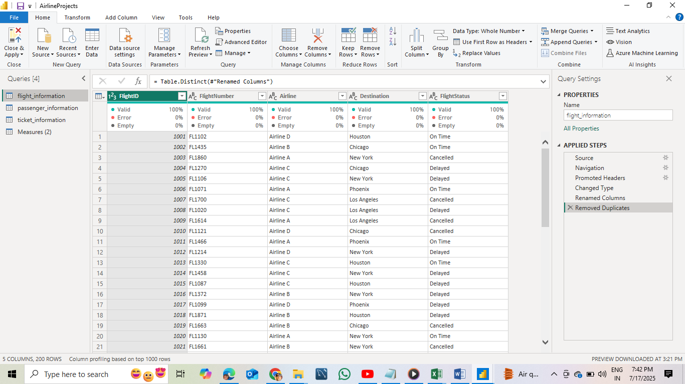

### **Task 2: Data Modeling**

* Created relationships between the three datasets using **FlightID** as the primary key.
* Configured relationships with correct **cardinality (One-to-Many)** and **cross-filter direction (Single)** to ensure accurate data flow.
* **Deliverable:** Screenshot of data model showing relationships.

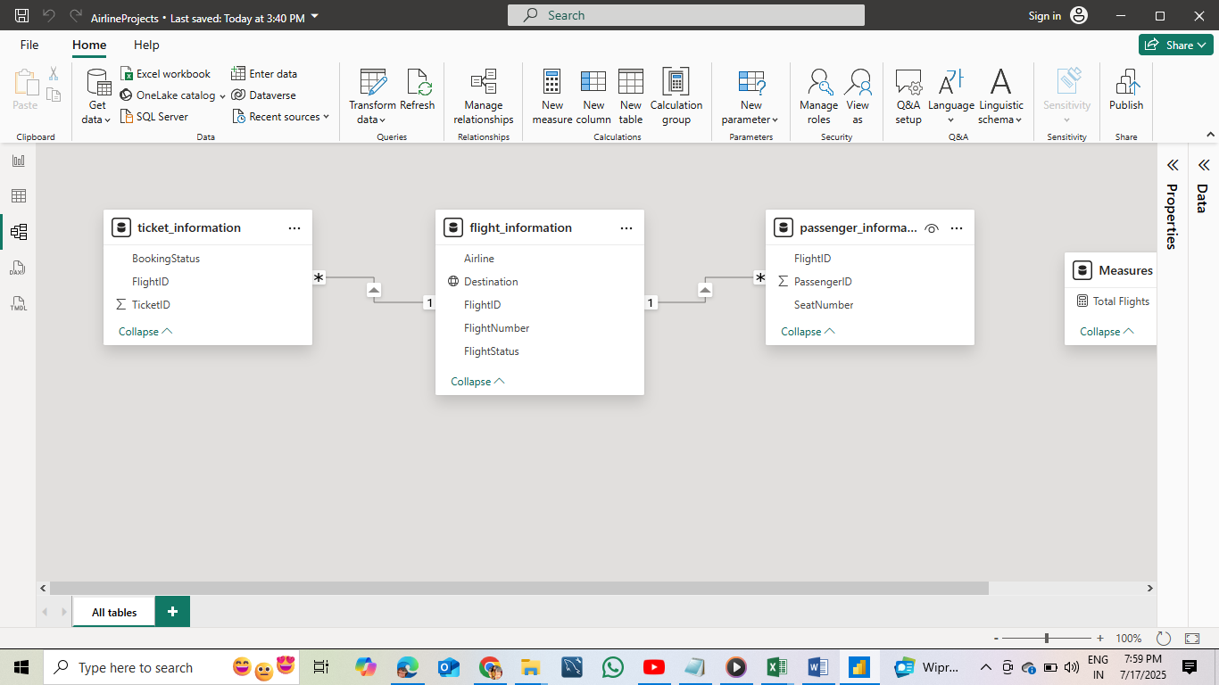

### **Task 3: Enhanced Data Insights**

* Added a **conditional column** to classify flights as “Best” or “To Be Improved” based on their status.
* Used **“Column from Examples”** feature to extract just the numeric flight number from the FlightNumber field.
* **Deliverable:** Screenshot of Power Query transformation steps.

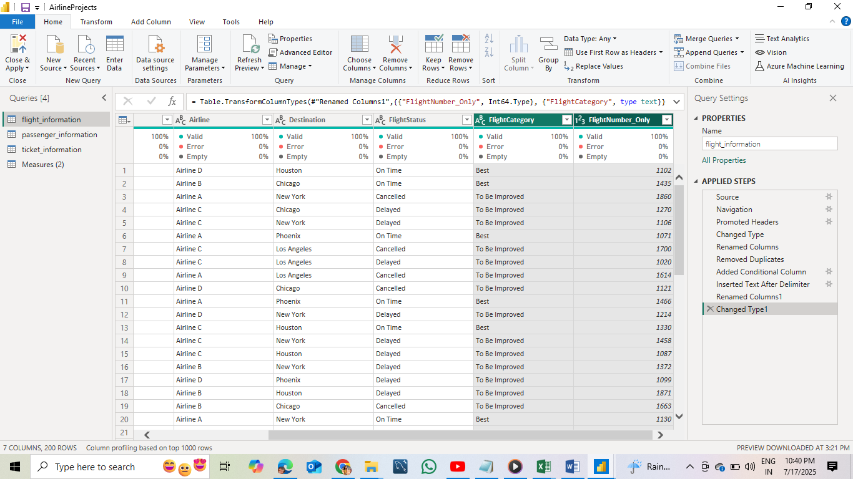

### **Task 4: Calculations Using DAX**

Performed DAX calculations for the following insights:

* **Total Passengers for a Specific Flight**
* Total Passengers = COUNT(Passenger_Information[PassengerID])
* **Total Tickets Booked**
* Tickets Booked = CALCULATE(COUNT(Ticket_Information[TicketID]), Ticket_Information[BookingStatus] = "Confirmed")
* **Filtered Table for “Best” Flights Only**
* Best Flights = FILTER(Flight_Information, Flight_Information[Status] = "Best")
* **Deliverable:** Screenshot of DAX calculations and output visuals.

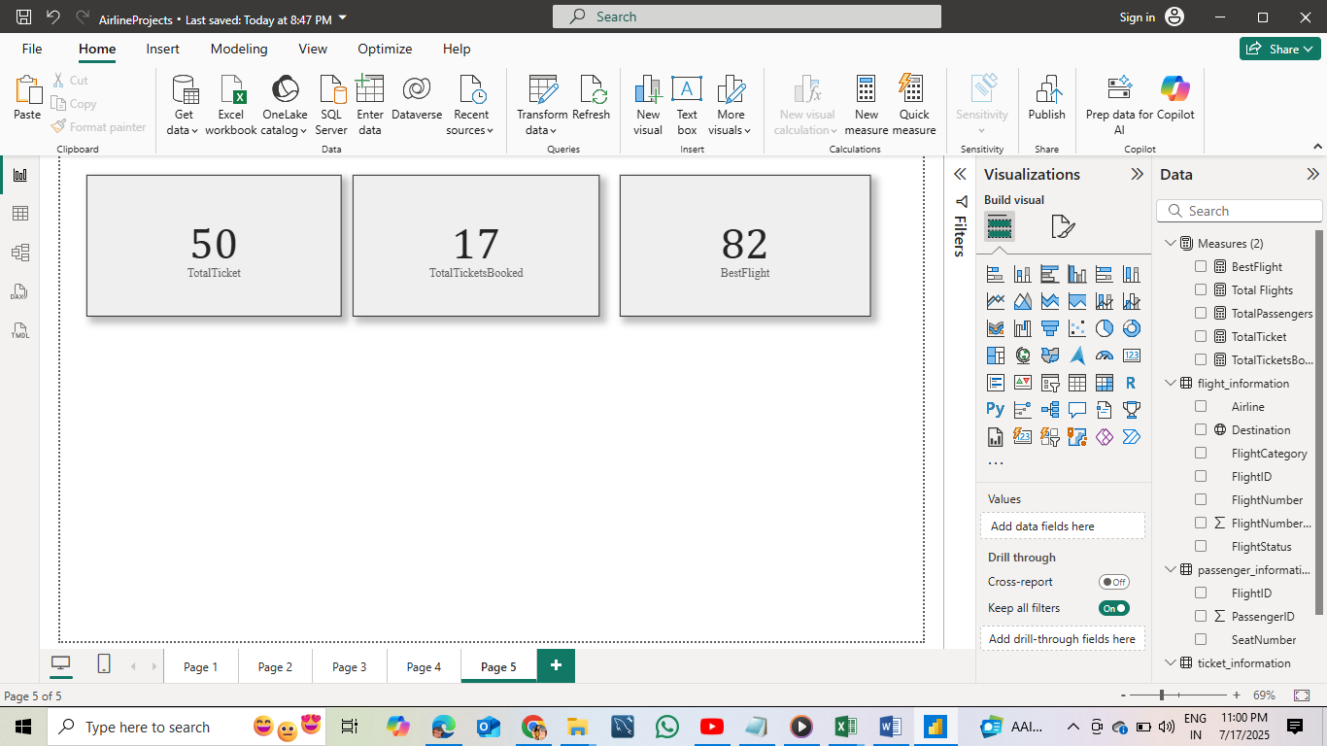

### **Task 5: Visualization and Interactive Features**

Created the following visuals in Power BI:

* **Passenger Count by Airline** – Bar chart
* **Ticket Booking Statuses** – Stacked column chart
* **Flights by Airline and Destination** – Matrix visual

Interactive Features:

* **Slicers** for Destination and Airline
* **Buttons/Bookmarks** for quick views
* **Airline-specific pages** with detailed breakdowns

**Deliverables:** Screenshots of all visuals and interactive features on separate report pages.

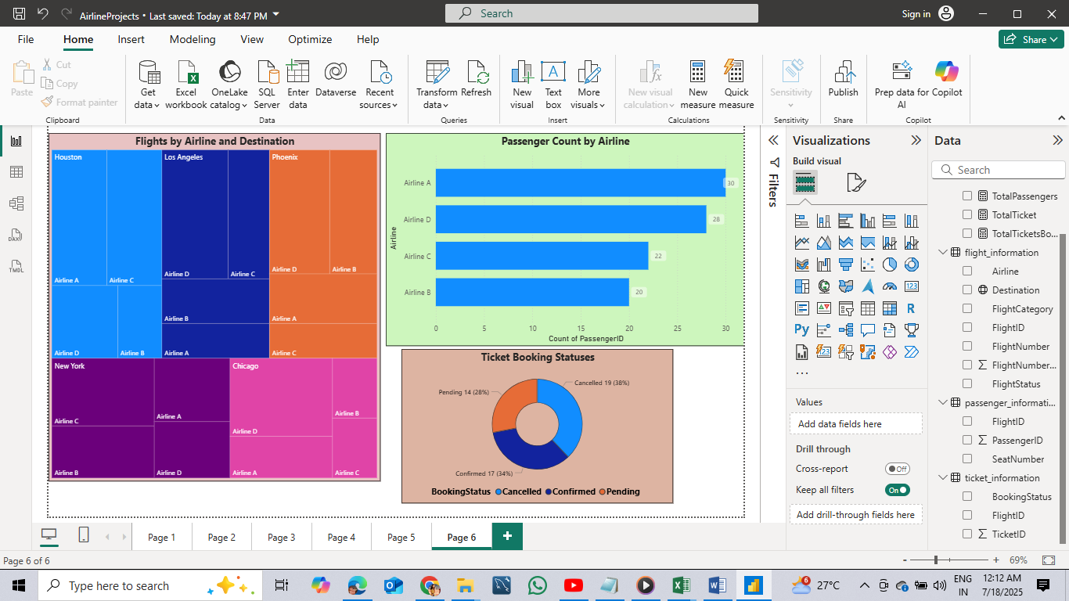

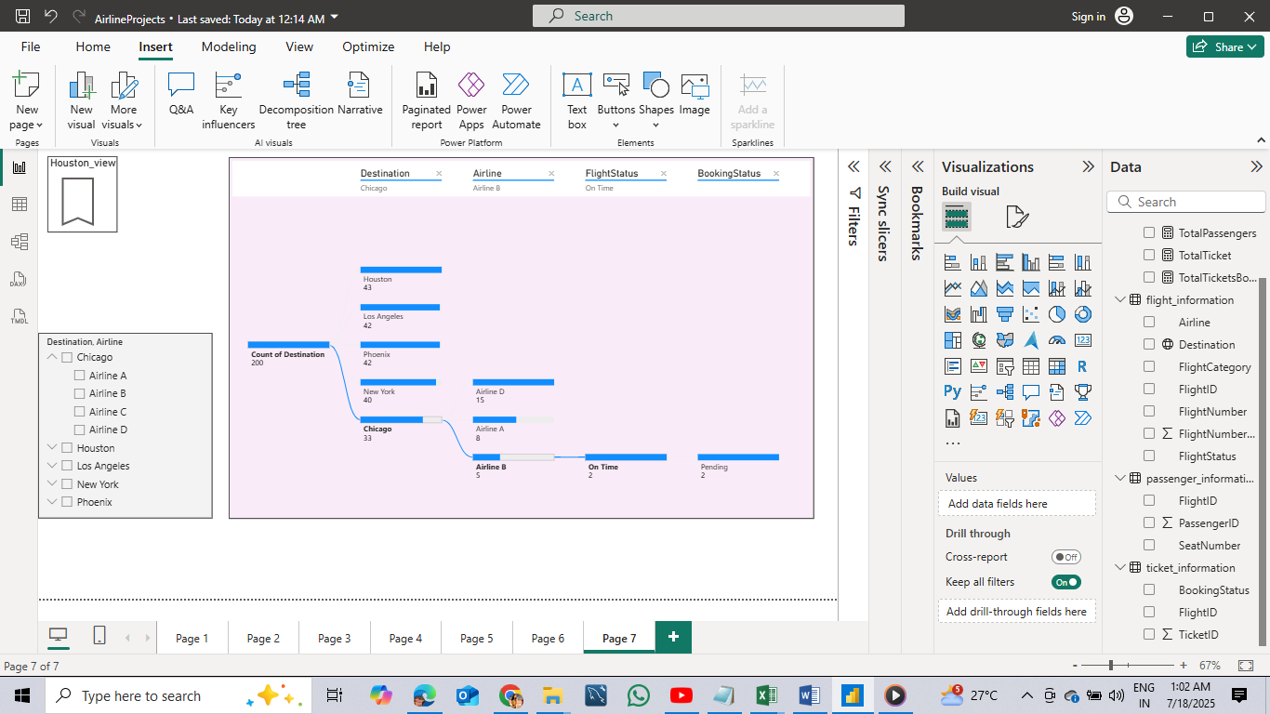

### **Task 6: Final Dashboard and Power BI Service**

* Designed a professional dashboard layout featuring a custom airplane watermark background.
* Key KPIs (e.g., Total Flights, Confirmed Bookings, Ticket Count) and trend visuals included.

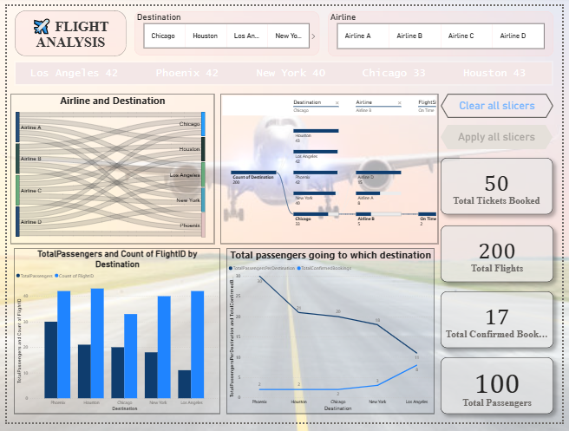

* Configured **Row-Level Security (RLS)** to restrict data access to “Los Angeles”.

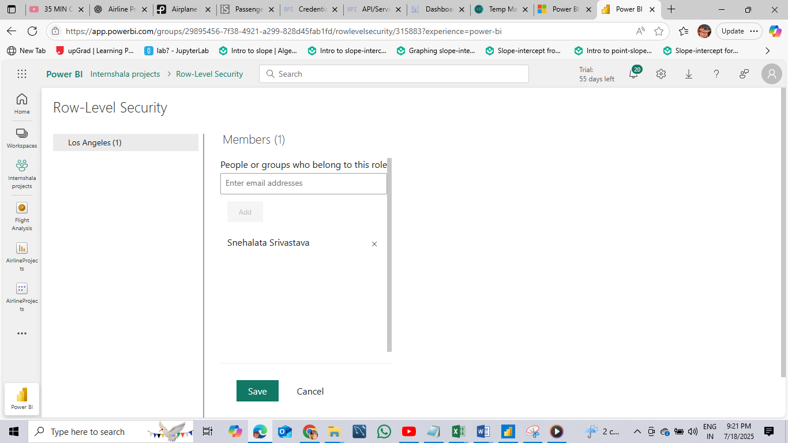

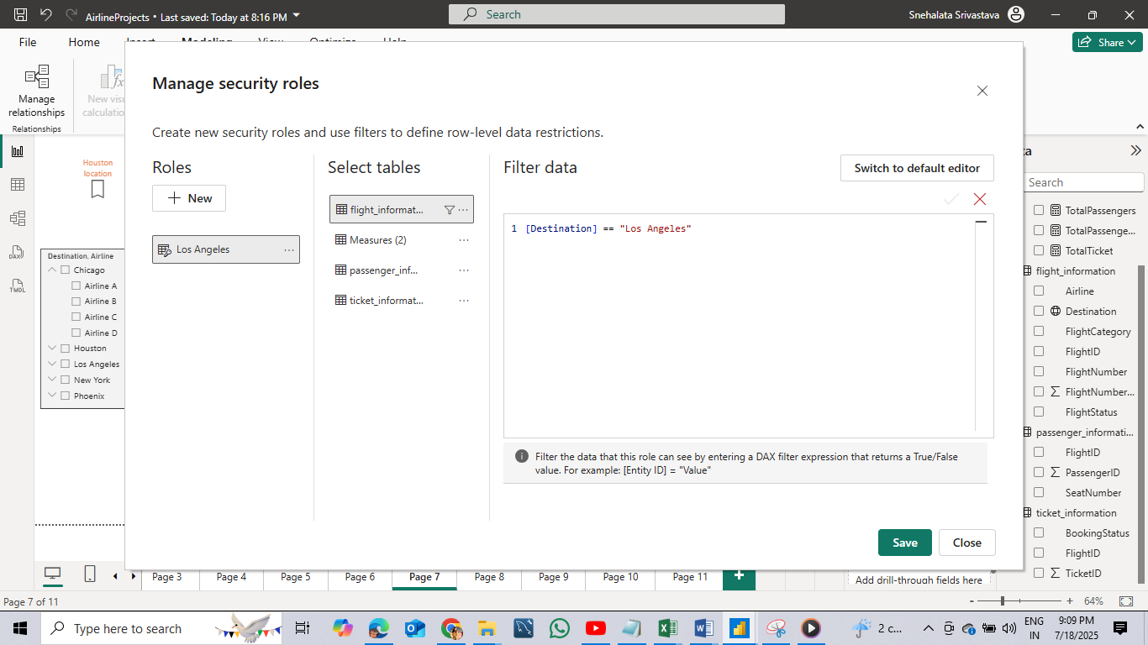

* Set up **scheduled refresh** at **5 PM daily** via Power BI Service.

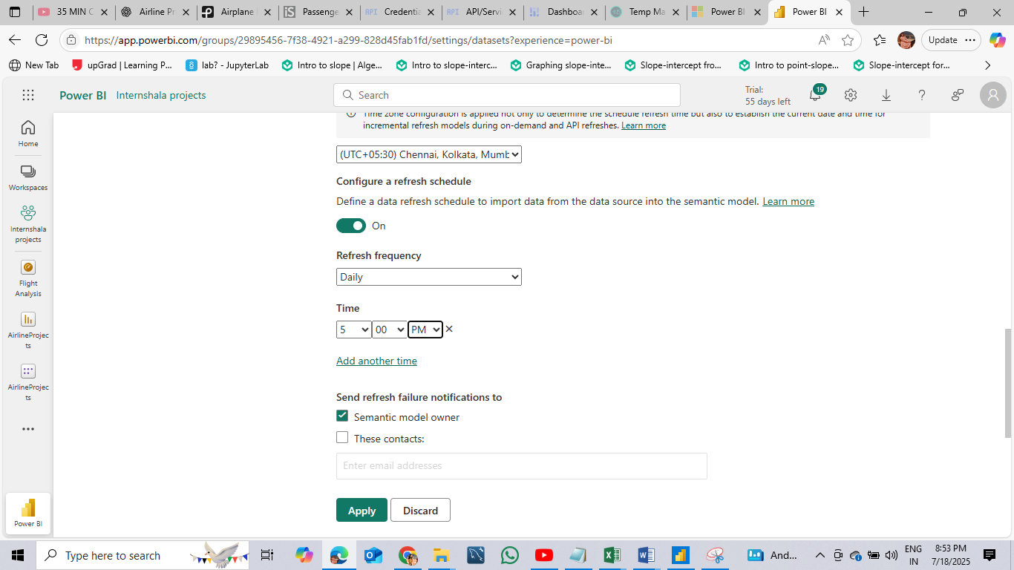

### **Key Findings and Insights**

* **Flight Performance Trends**: The analysis identified key performance indicators for each airline. Flights were successfully categorized into "Best" and "To Be Improved" based on their operational status, offering quick insight into airline efficiency.
* **Passenger Distribution**: The passenger count varied significantly across airlines, highlighting which carriers handled the most traffic. This metric can guide resource allocation and customer service focus.
* **Ticket Booking Patterns**: Booking status visuals revealed a clear proportion of confirmed versus cancelled tickets, providing a reliable metric for analyzing booking success rates.
* **Operational Bottlenecks**: Certain flights and destinations had lower performance or higher cancellation rates, pointing to possible operational issues or customer dissatisfaction that may require intervention.
* **Airline-Specific Behavior**: With the use of Row-Level Security (RLS), detailed insights were created for "Airline A", showcasing how airline-specific dashboards can support internal teams in tracking their own KPIs securely.
* **Interactive Exploration**: The use of slicers, filters, and drillthrough pages enabled a dynamic and user-friendly dashboard that empowers stakeholders to explore the data and gain insights without needing technical expertise.

These insights can help airline managers improve scheduling, optimize passenger experience, reduce cancellations, and drive strategic decisions for growth and operational excellence.

https://www.loom.com/share/b62adff97cc946788e66dd654baef99e?sid=b78599cf-2a83-46ad-8d0e-78e8f283ea78

**Prepared by:** Snehalata

**Tools Used:** Power BI, Power Query, DAX, Google Workspace

**Platform:** Internshala